Hung, Isaac, Jason, Quang

CS2103JAN2018-W15-B3

 https://github.com/CS2103JAN2018-W15-B3/main

FASTIS - MEETUP MANAGER



*USER GUIDE*

By: Team W15-B3 Since: February 2018 Licence: MIT

Contents

1. Introduction 3

2. Setting up 3

3. Features 5

3.1. Viewing help : help 5

3.2. Adding a person: add 5

3.3. Listing all persons : list 6

3.4. Editing a person : edit 6

3.5. Locating persons by name: find 7

3.6. Deleting a person : delete 7

3.7. Selecting a person: select 8

3.8. Listing entered commands : history 8

3.9. Change a group’s color: changeTagColor 9

3.10. Undoing previous command : undo 9

3.11. Redoing the previously undone command : redo 10

3.12. Adding a to-do: addToDo v1.2 10

3.13. Check a to-do as done: check v1.3 11

3.14. Uncheck a to-do as undone: uncheck v1.3 11

3.15. List Group Members: ListGroupMembers 12

3.16. Add Group: AddGroup 13

3.17. Display Calendar : display [coming in v2.0] 14

3.18. Schedule suitable time : schedule [coming in v2.0] 14

3.19. Edit a person’s group : modify [coming in v2.0] 15

3.20. Clearing all entries: clear 15

3.21. Exiting the program: exit 15

3.22. Saving the data 15

3.23. Encrypting data files [coming in v2.0] 16

4. FAQ 16

5. Appendix 16

5.1. Timetable Links 17

6. Command Summary 18

# Introduction

Fastis is a desktop application that aims to help students who are studying at National University of Singapore (NUS) manage their group projects effectively. The application enables students to keep track of group members’ timetables, information, meetups agendas, to-dos and schedule suitable meetup time.

This User Guide is meant to provides the necessary information for users who are interested in using Fastis. The guide consists of the set-up steps before using the application and the detailed descriptions of the application’s current features.

# Setting up

This section provides the set-up steps before using Fastis.

1. Ensure you have Java version 1.8.0_60 or later installed in your Computer.

|  |  |
| --- | --- |
| 💡 | Having any Java 8 version is not enough.  This app will not work with earlier versions of Java 8. |

1. Download the latest Fastis.jar [here](https://github.com/CS2103JAN2018-W15-B3/main/releases)
2. Copy the file to the folder you want to use as the home folder for Fastis.
3. Double-click the file to start the app. The GUI should appear in a few seconds as in Figure 1.

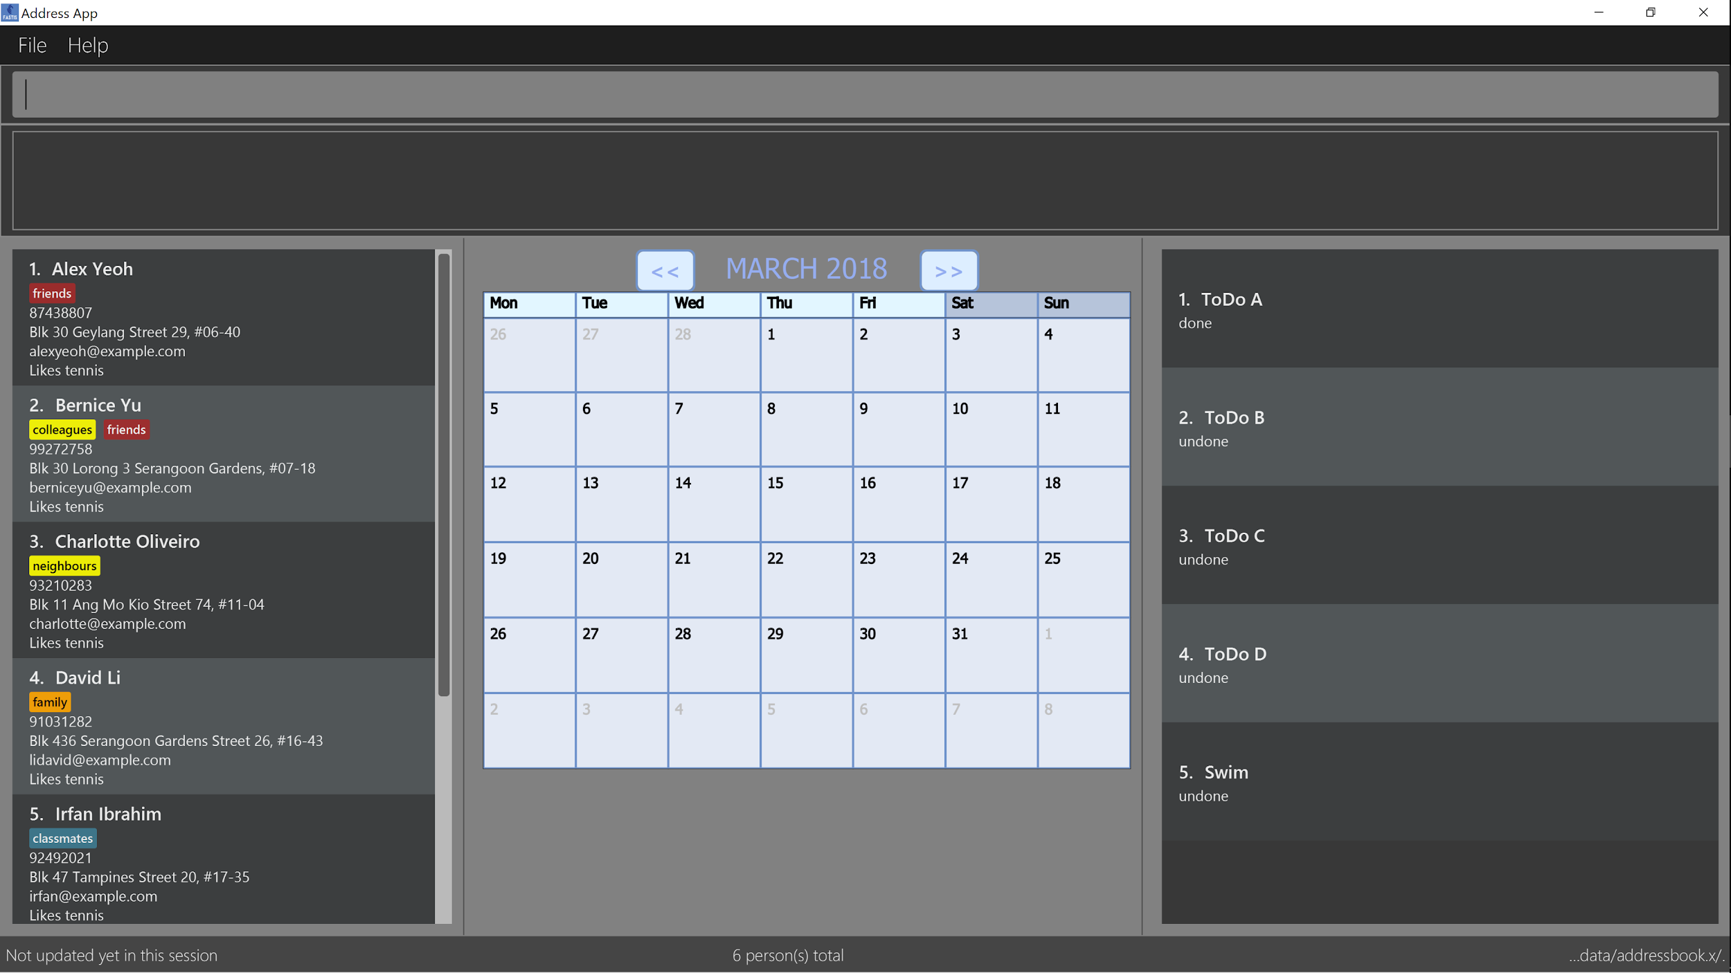

Figure The GUI when Fastis is run

1. Type the command in the command box and press Enter to execute it.

e.g. typing help and pressing Enter will open the help window.

1. Some example commands you can try:
   * **list** : lists all contacts
   * **add n**/John Doe p/98765432 e/johnd@example.com a/John street, block 123, #01-01 : adds a contact named John Doe to the Fastis.
   * Delete 3 : deletes the 3rd contact shown in the current list
   * exit : exits the app
2. Refer to Section 3. Features for details of each command.

# Features

This section provides the command formats, with examples, of Fastis’ current features.

Command Format

* Some commands have an alias, which you can also use to execute the command e.g. to add a person to Fastis, you can type either add n/John Doe or a n/John Doe.
* Words in UPPER_CASE are the parameters to be supplied by the user e.g. in add n/NAME, NAME is a parameter which can be used as add n/John Doe.
* Items in square brackets are optional e.g n/NAME [t/TAG] can be used as n/John Doe t/friend or as n/John Doe.
* Items with …​ after them can be used multiple times including zero times e.g. [t/TAG]…​ can be used as (i.e. 0 times), t/friend, t/friend t/family etc.
* Parameters can be in any order e.g. if the command specifies n/NAME p/PHONE_NUMBER, p/PHONE_NUMBER n/NAME is also acceptable.

## Viewing help : help

Shows the Help Window which displays the formats of all available commands of Fastis

Format: help

## Adding a person: add

Adds a person to Fastis.

Alias: a

Format: add n/NAME p/PHONE_NUMBER e/EMAIL a/ADDRESS l/TIMETABLE_LINK d/DETAIL [t/TAG]…​

|  |  |
| --- | --- |
| 💡 | A person can have any number of groups (including 0) |
| ℹ️ | See Appendix: getting NUSmods link on how get a person’s TIMETABLE_LINK |

Examples:

* add n/John Doe p/98765432 e/johnd@example.com a/John street, block 123, #01-01 l/http://modsn.us/MYwiD d/Likes tennis
* add n/Betsy Crowe t/friend e/betsycrowe@example.com a/Newgate Prison p/1234567 l/http://modsn.us/56Dn9 d/Likes tennis t/criminal

## Listing all persons : list

Shows a list of all persons in Fastis.

Alias: l

Format: list

## Editing a person : edit

Edits an existing person in Fastis.

Alias: e

Format: edit INDEX [n/NAME] [p/PHONE] [e/EMAIL] [a/ADDRESS] [l/TIMETABLE_LINK] [d/DETAIL] [t/TAG]…​

* Edits the person at the specified INDEX. The index refers to the index number shown in the last person listing. The index must be a positive integer 1, 2, 3, …​
* At least one of the optional fields must be provided.
* Existing values will be updated to the input values.
* When editing groups, the existing groups of the person will be removed i.e adding of groups is not cumulative.
* You can remove all the person’s groups by typing t/ without specifying any groups after it.

Examples:

* edit 1 p/91234567 e/johndoe@example.com

Edits the phone number and email address of the 1st person to be 91234567 and johndoe@example.com respectively.

* edit 2 n/Betsy Crower t/

Edits the name of the 2nd person to be Betsy Crower and clears all existing groups.

## Locating persons by name: find

Finds persons whose names contain any of the given keywords.

Alias: f

Format: find KEYWORD [MORE_KEYWORDS]

* The search is case insensitive. e.g hans will match Hans
* The order of the keywords does not matter. e.g. Hans Bo will match Bo Hans
* Only the name is searched.
* Only full words will be matched e.g. Han will not match Hans
* Persons matching at least one keyword will be returned (i.e. OR search). e.g. Hans Bo will return Hans Gruber, Bo Yang

Examples:

* find John

Returns john and John Doe

* find Betsy Tim John

Returns any person having names Betsy, Tim, or John

## Deleting a person : delete

Deletes the specified person from Fastis.

Alias: d

Format: delete INDEX

* Deletes the person at the specified INDEX.
* The index refers to the index number shown in the most recent listing.
* The index must be a positive integer 1, 2, 3, …​

Examples:

* list

delete 2

Deletes the 2nd person in Fastis.

* find Betsy

delete 1

Deletes the 1st person in the results of the find command.

## Selecting a person: select

Selects the person identified by the index number used in the last person listing.

Alias: s

Format: select INDEX

* Selects the person and loads the Google search page the person at the specified INDEX.
* The index refers to the index number shown in the most recent listing.
* The index must be a positive integer 1, 2, 3, …​

Examples:

* list

select 2

Selects the 2nd person in Fastis.

* find Betsy
* select 1
* Selects the 1st person in the results of the find command.

## Listing entered commands : history

Lists all the commands that you have entered in reverse chronological order.

Alias: h

Format: history

|  |  |
| --- | --- |
| ℹ️ | Pressing the ↑ and ↓ arrows will display the previous and next input respectively in the command box. |

## Change a group’s color: changeTagColor

Change a specific group color to one of the supported colors.

Alias: color

Format changeTagColor TAG COLOR

* The TAG specified must belong to one of the people in Fastis
* Available COLORS are: teal, red, yellow, blue, orange, brown, green, pink, black, grey

## Undoing previous command : undo

Restores Fastis to the state before the previous *undoable* command was executed.

Alias: u

Format: undo

|  |  |
| --- | --- |
| ℹ️ | Undoable commands: those commands that modify Fastis’s content (add, delete, edit and clear). |

Examples:

* delete 1

list

undo (reverses the delete 1 command)

* select 1

list

undo

The undo command fails as there are no undoable commands executed previously.

* delete 1

clear

undo (reverses the clear command)

undo (reverses the delete 1 command)

## Redoing the previously undone command : redo

Reverses the most recent undo command.

Alias: r

Format: redo

Examples:

* delete 1

undo (reverses the delete 1 command)

redo (reapplies the delete 1 command)

* delete 1

redo

The redo command fails as there are no undo commands executed previously.

* delete 1
* clear
* undo (reverses the clear command)
* undo (reverses the delete 1 command)
* redo (reapplies the delete 1 command)
* redo (reapplies the clear command)

## Adding a to-do: addToDo v1.2

Adds a to-do to Fastis.

Alias: aTD

Format: addToDo CONTENT

|  |  |
| --- | --- |
| 💡 | A to-do should not have an empty content |

Examples:

* addToDo Do homework before next Wednesday
* aTD Swim like a fish

Figure 2 shows the result of the above command:

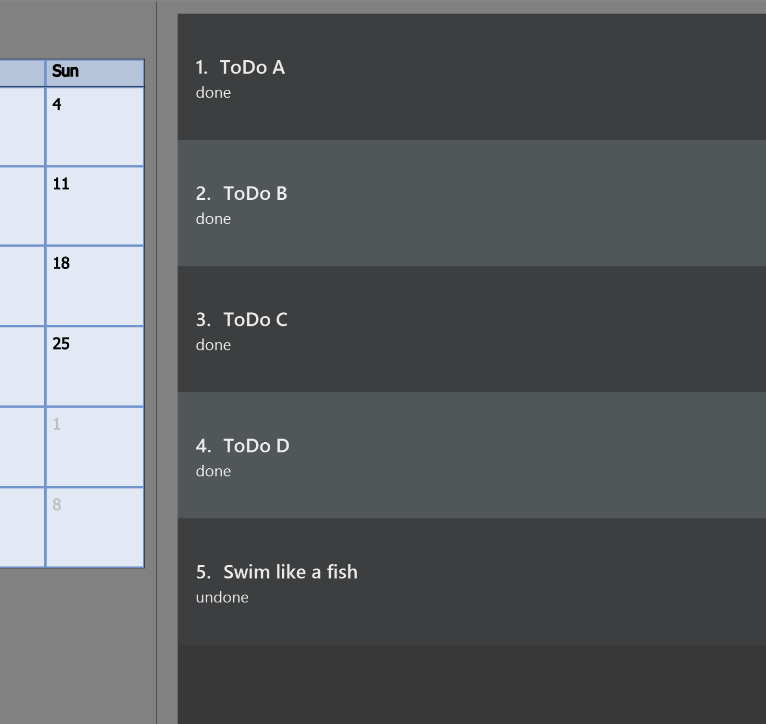

Figure Example of to-dos

## Check a to-do as done: check v1.3

Checks a to-do in Fastis as done

Format: check INDEX

|  |  |
| --- | --- |
| 💡 | INDEX should not be 0 or larger then the size of the to-do list |

Examples:

* check 1

## Uncheck a to-do as undone: uncheck v1.3

Unchecks a to-do in Fastis as undone

Format: uncheck INDEX

|  |  |
| --- | --- |
| 💡 | INDEX should not be 0 or larger then the size of the to-do list |

Examples:

* uncheck 1

## List Group Members: ListGroupMembers

List out all persons with the given keywords(group tags).

Alias: lgm

Format: ListGroupMembers INPUT

* The search is case insensitive. e.g cs1010 will match CS1010
* Only the name is searched.

Examples:

* ListGroupMembers CS3230 CS1010

Returns any person having group tags CS3230, CS1010 Refer to Figure 3 for example.

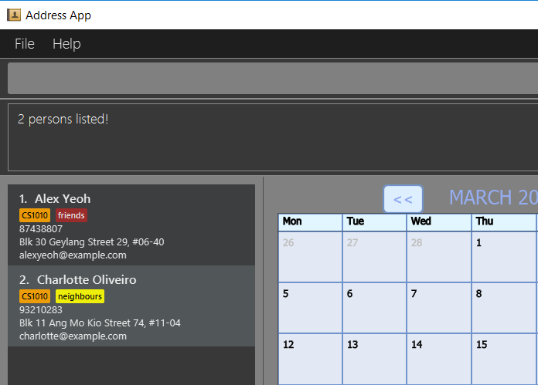

Figure Example of ListGroupMembers with CS1010 tag.

## Add Group: AddGroup

Creates a group named KEYWORD

Alias: aG

Format: aG KEYWORD[KEYWORDS]

|  |  |
| --- | --- |
| ℹ️ | Keyword cannot be an empty input. |

Examples:

* addGroups CS2101 Oral Presentation

New Group CS2101 Oral Presentation added, refer to Figure 4.

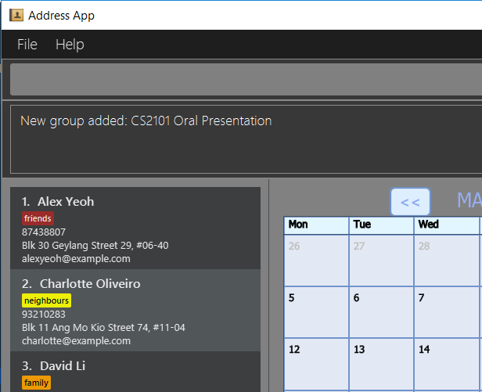

Figure Example of add Group

## Display Calendar : display [coming in v2.0]

Show all the group meeting in list in Calendar in time order.

Alias: d

Format: display

## Schedule suitable time : schedule [coming in v2.0]

Compute a time suitable for all group members to meet.

Alias: s

Format: schedule GROUP

* GROUP refers the name of group which you want to work with.
* The name of the group entered must already exist in FASTIS or saved by your previously.

## Edit a person’s group : modify [coming in v2.0]

Modify the group that the person belongs to.

Alias: m

Format: modify INDEX

* INDEX refers to the index of the person you are trying to update his group.
* The index must be a positive integer 1, 2, 3, …​

## Clearing all entries: clear

Clears all entries from Fastis.

Alias: c

Format: clear

## Exiting the program: exit

Exits the program.

Format: exit

## Saving the data

Fastis’s data are saved in the hard disk automatically after any command that changes the data.

There is no need to save manually.

## Encrypting data files [coming in v2.0]

Personal log in page that requires saved password.

Sign up with username and password.

Creation of password should use at least 1 lower case ,1 upper case and 1 number.

Sign in with saved username and password to be able to use the secured application.

Data files created by FASTIS will be encrypted using the password you have provided.

# FAQ

This section provides the common questions and answers that users may encounter while using Fastis.

Q: How do I transfer my data to another Computer?

A: Install the app in the other computer and overwrite the empty data file it creates with the file that contains the data of your previous Fastis folder.

# Appendix

This section provides additional information of terms and definitions used in this User Guide.

## Timetable Links

Timetable links can be retrieved from the NUSmods website:

1. Go the NUSMods website and click the share button (Figure 5).

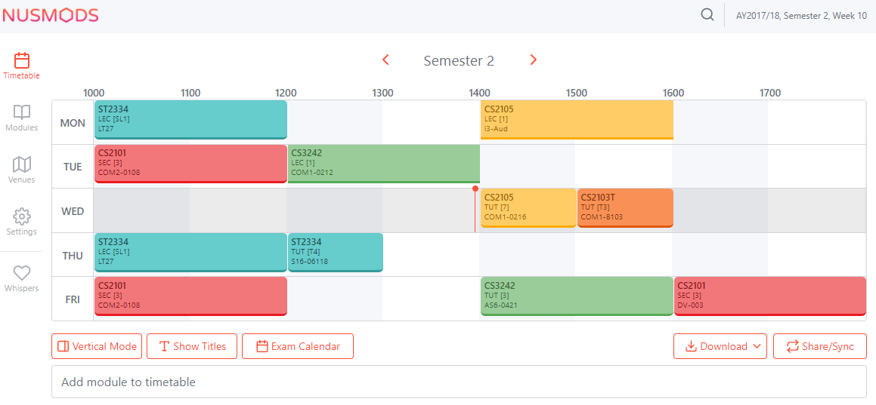

Figure Share Button on NUSmods.com

1. Copy the URL and paste it where needed (Figure 6).

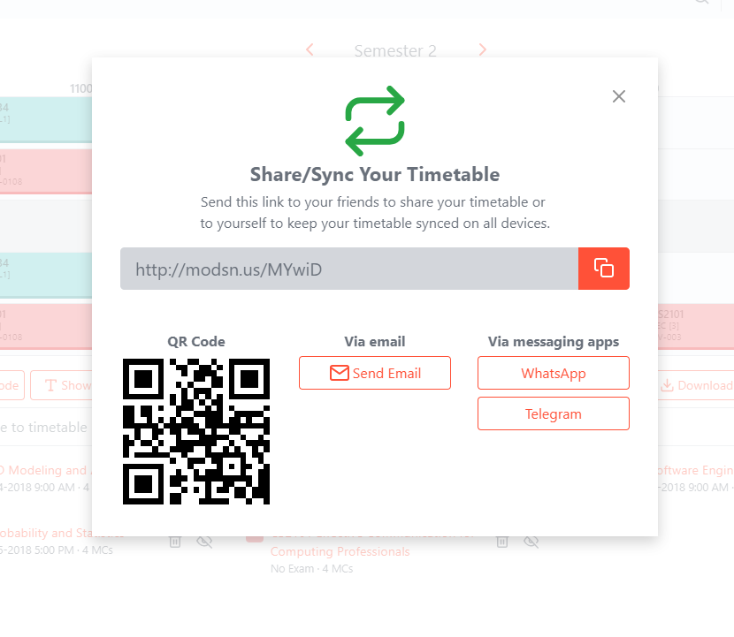

Figure Timetable Link from NUSmods.com

# Command Summary

This section aims to provide seasoned users all commands formats at a glance. Refer to Section 3: Features – command format for help with understanding command syntax.

* Add add n/NAME p/PHONE_NUMBER e/EMAIL a/ADDRESS [t/TAG]…​

e.g. add n/James Ho p/22224444 e/jamesho@example.com a/123, Clementi Rd, 1234665 t/friend t/colleague

* AddToDo : addToDo CONTENT

e.g. addToDo Do home work

CheckToDo : check INDEX

e.g. check 3

UnCheckToDo : uncheck INDEX

e.g. uncheck 3

* Clear : clear

Delete : delete INDEX

e.g. delete 3

Edit : edit INDEX [n/NAME] [p/PHONE_NUMBER] [e/EMAIL] [a/ADDRESS] [t/TAG]…​

e.g. edit 2 n/James Lee e/jameslee@example.com

Find : find KEYWORD [MORE_KEYWORDS]

e.g. find James Jake

* List : list
* Help : help

Select : select INDEX

e.g. select 2

* History : history
* Undo : undo
* Redo : redo